**AI Enhanced Navigation Suggestion System**

A PROJECT REPORT [INTERNSHIP REPORT]

#### **Submitted by**

#### Puneet V H [RA2211028010222]

#### Sasikrishna A [RA2211030010297]

***Under the Guidance of***

**Dr. Ushasukhanya S**

(Assistant Professor, NWC)

## **BACHELOR OF TECHNOLOGY**

## **in**

## **COMPUTER SCIENCE ENGINEERING**

## **with specialization in (Cyber Security and Cloud Computing)**

|  |  |
| --- | --- |
|  |  |
|  |  |

## **DEPARTMENT OF NETWORKING AND COMMUNICATIONS COLLEGE OF ENGINEERING AND TECHNOLOGY**

SRM INSTITUTE OF SCIENCE AND TECHNOLOGY

## **KATTANKULATHUR- 603 203**

APRIL 2024

# **SRM INSTITUTE OF SCIENCE AND TECHNOLOGY**

# **KATTANKULATHUR – 603 203**

## **BONAFIDE CERTIFICATE**

Certified that 21CSE292P project report [21CSE292P semester internship report] Titled “**AI ENHANCED NAVIGATION SUGGESTION SYSTEM**” is the Bonafide work of “**PUNEET VH [RA2211028010222], A SASIKRISHNA [RA22110300297]”** who carried out the project work[internship] under my supervision. Certified further, that to the best of my knowledge the work reported here does not form any other project report or dissertation based on which a degree or award was conferred on an earlier occasion on this or any other candidate.

**SIGNATURE** **SIGNATURE**

**Dr. Ushasukhanya S Dr. Annapurani Panaiyappan .K**

**SUPERVISOR HEAD OF THE DEPARTMENT**

**Assitant Professor**   **NWC**

**NWC**

# **Own Work Declaration**

The aim of our invention is to create a system (UI) where we can navigate a user to reach his destination by suggesting an efficient route. This efficient route is based on the events that is scheduled to happen in the date, time and location (route) of the travel, A chat bot to display news about events which is going to happen in expected time of travel such as local festivals, campaigns etc will be created and we will be leveraging artificial intelligence API’s and ML models to predict traffic patterns based on real time and historical data of expected events in that route in advance. And will generate dynamic route suggestions that optimize travel time and minimize disruptions or traffic. Through this innovative fusion of technology and user-centric design, our aim is to redefine the navigation experience, offering users not just directions, but intelligent and adaptive guidance that enhances their overall travel experience.

# **Acknowledgement**

We express our heartfelt thanks to our honorable Vice

Chancellor **Dr. C. MUTHAMIZHCHELVAN**, for being the

beacon in all our endeavors.

We would like to express my warmth of gratitude to our

Registrar **Dr. S. Ponnusamy**, for his encouragement.

We express our profound gratitude to our Dean (College of

Engineering and Technology) **Dr. T. V.Gopal**, for bringing

out novelty in all executions.

We would like to express my heartfelt thanks to Chairperson,

School of Computing **Dr. Revathi Venkataraman**, for

imparting confidence to complete my course project.

We are highly thankful to our Course project Faculty

**Dr. Ushasukhanya S**, Assistant Professor, Networking and

Communications, for her assistance, timely suggestion and

guidance throughout the duration of this course project.

**Abstract**

The AI Enhanced Navigation Suggestion System is an innovative solution designed to optimize route suggestions for users based on real-time traffic conditions, historical data, and upcoming local events. The system leverages Artificial Intelligence (AI) and Machine Learning (ML) models to analyze and predict traffic patterns. It also incorporates Internet of Things (IoT) devices like magnetic sensors and Raspberry Pi camera modules for real-time data collection.

A unique feature of this system is its chatbot component, which delivers personalized event updates during travel, enhancing user experience. The system dynamically adjusts routes based on real-time traffic conditions and local events, providing context-aware route recommendations. This represents a significant advancement over traditional static navigation systems.

The system has potential applications in urban commuting, tourism, and fleet management. It can be integrated into existing navigation apps and ride-sharing platforms, providing efficient routes, cost savings, and timely deliveries. The system also contributes to environmental sustainability by reducing fuel consumption and emissions through efficient routing.

The AI Enhanced Navigation Suggestion System is a novel integration of traffic prediction with real-time traffic information and historical information about local events. This integration aims to provide more accurate and context-aware route suggestions, enhancing traffic efficiency, user experience, and safety. The system represents a significant societal impact, offering solutions to urban congestion, environmental concerns, and enhancing overall transportation efficiency.

The system’s adaptability to real-time changes sets it apart from traditional navigation systems. It not only responds to immediate traffic conditions but also anticipates changes based on local events. This proactive approach ensures a seamless travel experience. Furthermore, the system’s integration with IoT devices enhances its data collection capabilities, providing a more comprehensive understanding of the traffic environment. The system’s user-centric design, particularly the chatbot component, ensures that users are always informed and engaged during their journey. This invention represents a significant leap forward in navigation technology.

In summary, the AI Enhanced Navigation Suggestion System is a comprehensive solution that combines AI, ML, IoT, and user-centric design to revolutionize the way we navigate our cities, making travel more efficient, safe, and enjoyable.

* **Introduction to Novel Approach:** This study introduces a groundbreaking method to improve user navigation in urban environments using artificial intelligence (AI) for real time traffic prediction.
* **Data Analysis for Prediction:** The system relies on the analysis of historical data and current events, considering factors like local festivals, campaigns, accidents, and road closures.
* **Dynamic Route Suggestions:** Our AI-driven system generates dynamic route suggestions, responding to real-time conditions and optimizing travel time for users.
* **Minimizing Disruptions:** By factoring in local events and incidents, the system aims to minimize disruptions, ensuring smoother navigation experiences.
* **Adaptability to Changing Conditions:** The proposed navigation system is designed to adapt to changing conditions, providing users with intelligent and efficient route recommendations.
* **Real-time Traffic Prediction:** Utilizing AI, the system predicts traffic patterns in real time, enhancing its ability to offer timely and relevant route suggestions.
* **Optimization of Travel Time:** The primary goal is to optimize travel time for users, considering both historical traffic data and current dynamic events.
* **Mitigation of Unforeseen Events:** The system addresses the impact of unforeseen events, such as accidents or road closures, by dynamically adjusting route recommendations.
* **User-Centric Approach:** The focus is on providing users with a seamless and efficient navigation experience tailored to the unique challenges of urban settings.
* **AI-Driven Intelligence:** The system's intelligence is driven by AI algorithms, enabling it to continuously learn and improve its predictions and recommendations.
* **Efficient Route Recommendations:** By leveraging AI, the system enhances the efficiency of route recommendations, considering the diverse and ever-changing urban landscape.
* **Overall Impact:** The research signifies a significant step forward in revolutionizing urban navigation, offering a solution that not only adapts to changing conditions but also contributes to the evolution of intelligent transportation systems.

# **Table of Content**

|  |  |
| --- | --- |
| S.NO | TOPIC |
| 1. | Cover Page |
| 2. | Bonafide Certificate |
| 3. | Own work Declaration |
| 4. | Acknowledgement |
| 5. | Abstract |
| 6. | List of Symbols and  Abbreviations |
| 7. | Chapter 1  1.1 Introduction  1.2 Literature Review  1.3 Methodology  1.4 Result  1.5 Discussion  1.6 Conclusion |
| 8. | References |
| 9. | Code and output |

# **List of Symbols and Abbreviations**

* AI (Artificial Intelligence): AI refers to the simulation of human intelligence processes by machines, especially computer systems. These processes include learning, reasoning, problem-solving, perception, and language understanding.
* ML (Machine Learning): ML is a type of AI that allows software applications to become more accurate in predicting outcomes without being explicitly programmed. It focuses on the development of computer programs that can access data and use it to learn for themselves.
* IoT (Internet of Things): IoT is a system of interrelated computing devices, mechanical and digital machines, objects, animals, or people that are provided with unique identifiers (UIDs) and the ability to transfer data over a network without requiring human-to-human or human-to-computer interaction.
* Chatbot: A chatbot is a software application used to conduct an online chat conversation via text or text-to-speech, in lieu of providing direct contact with a live human agent.
* Raspberry Pi: Raspberry Pi is a series of small single-board computers developed in the United Kingdom by the Raspberry Pi Foundation to promote the teaching of basic computer science in schools and in developing countries.
* Magnetic Sensors: Magnetic sensors are used to detect magnetic fields. In the context of this project, they are used to detect vehicle movement and provide live traffic data.
* Real-Time Adaptation: This refers to the system’s ability to dynamically adjust based on real-time traffic conditions and local events.
* Context-Aware Suggestions: This refers to the system’s ability to provide route suggestions that consider the user’s specific travel context, such as local events and road closures.
* User-Centric Design: This refers to an approach to designing the system where the needs, wants, and limitations of the end user are given extensive attention at each stage of the design process.
* Dynamic Route Optimization: This is the process of determining the most cost-effective route. It’s dynamic because it can adjust based on changing conditions, such as traffic or road closures.
* NEWSAPI: News API is a JSON-based API that provides articles from over 30,000 worldwide news sources and blogs. It can be used to retrieve live news articles, which can be useful for keeping the system updated with real-time events.
* OPENSTREETMAP: OpenStreetMap is a collaborative project to create a free editable map of the world. It provides geospatial data and map images, which can be used for route planning and navigation.
* Bing Maps: Bing Maps is a web mapping service provided by Microsoft. It offers various features including street maps, 3D maps, driving or transit direction, traffic information, etc. It can be used for route calculation, local search, and location recognition.
* Parse Hub: Parse Hub is a web scraping tool that can extract data from dynamic websites. It can be used to gather event information from various sources, which can then be used to inform the system’s route suggestions.
* Gemini AI: Gemini AI is a suite of AI tools and APIs that can be used for various purposes, including text analysis, sentiment analysis, and predictive modeling. In the context of this project, it could be used to analyze traffic data and predict traffic patterns.
* TomTom API: TomTom API is a service provided by TomTom, a global leader in navigation and mapping products. The API provides developers with access to a variety of services, including routing, geocoding, maps, and traffic information. It can be used to get real-time traffic information and calculate optimal routes.

# **Chapter**

**Introduction:**

Navigating urban environments efficiently has become increasingly challenging due to dynamic factors like local events, accidents, and road closures. This study introduces an innovative solution: an AI-powered dynamic navigation system. By analyzing historical data and current events, the system predicts traffic patterns, enabling it to generate real-time, context-aware route recommendations. This approach aims to optimize travel time and minimize disruptions, addressing the limitations of traditional navigation systems in evolving urban landscapes. The AI Enhanced Navigation Suggestion System is a groundbreaking project that aims to revolutionize the way we navigate our cities. The system is designed to provide optimal route suggestions for users based on real-time traffic conditions, historical data, and upcoming local events. This is achieved through the integration of Artificial Intelligence (AI) and Machine Learning (ML) models, which analyze and predict traffic patterns, and Internet of Things (IoT) devices, which collect real-time data.

A unique feature of this system is its chatbot component, which delivers personalized event updates during travel, enhancing the user experience. This user-centric approach sets our system apart from traditional navigation systems, which often rely on static routes and do not account for real-time changes in traffic conditions. The system has potential applications in various sectors, including urban commuting, tourism, and fleet management. It can be integrated into existing navigation apps and ride-sharing platforms, providing efficient routes, cost savings, and timely deliveries. Furthermore, the system contributes to environmental sustainability by reducing fuel consumption and emissions through efficient routing.

In summary, the AI Enhanced Navigation Suggestion System is a comprehensive solution that combines AI, ML, IoT, and user-centric design to make travel more efficient, safe, and enjoyable. This project represents a significant leap forward in navigation technology, with the potential to significantly impact society and the environment.

The system's adaptability to real-time changes sets it apart from traditional navigation systems. It not only responds to immediate traffic conditions but also anticipates changes based on local events. This proactive approach ensures a seamless travel experience. Furthermore, the system's integration with IoT devices enhances its data collection capabilities, providing a more comprehensive understanding of the traffic environment. The system's user-centric design, particularly the chatbot component, ensures that users are always informed and engaged during their journey. This invention represents a significant leap forward in navigation technology.

The societal impact of this invention is considerable. By dynamically optimizing routes based on real-time traffic conditions and historical traffic data of local events, our system can reduce travel time, ease congestion, and enhance overall transportation efficiency. Additionally, efficient routing leads to reduced fuel consumption and lower emissions, contributing to environmental sustainability. The chatbot component delivers event updates during travel, enhancing user satisfaction and safety. The system can be integrated into existing navigation apps and ride-sharing platforms, providing efficient routes, cost savings, and timely deliveries. This invention represents a significant societal impact, offering solutions to urban congestion, environmental concerns, and enhancing overall transportation efficiency.

**Literature Review:**

Our invention aims to revolutionize the navigation experience by integrating artificial intelligence (AI) and machine learning (ML) into a user friendly interface (UI) that suggests efficient routes based on real-time and historical data of scheduled events. This innovative approach builds upon existing research that emphasizes the integration of AI and real-time data analysis in navigation systems. By leveraging AI APIs and ML models, our system predicts traffic patterns by considering both real time conditions and historical data associated with scheduled events along the route. This aligns with prior studies that highlight the importance of incorporating real time traffic information into navigation algorithms to provide users with timely and relevant route recommendations. Furthermore, our system incorporates a chatbot component to deliver news about upcoming events, such as local festivals and campaigns, enhancing the user experience during travel. This user-centric approach resonates with research emphasizing the significance of personalized recommendations and user-centric design principles in navigation interfaces. Overall, by combining AI, ML, and user-centric design, our invention aims to redefine the navigation experience, offering users intelligent and adaptive guidance that optimizes travel time and minimizes disruptions, thereby enhancing their overall travel experience and contributing to the evolution of intelligent transportation systems.

**Methodology:**

We detail the design and implementation of our AI Enhanced Navigation Suggestion System. We discuss the AI APIs used for traffic prediction and the user-centric design elements that ensure personalized and efficient navigation. A method for providing dynamic route suggestions to users based on real time traffic conditions, historical data of upcoming local events, comprising steps of:

* Collecting traffic data from various sources.
* Analyzing historical and real time traffic patterns using machine learning models.
* Identifying local events relevant to the user’s travel time and predicting traffic due to it.
* Generating route suggestions that optimize travel time and minimize disruptions or traffic.

**Results:**

We present the results of testing our system in various urban environments and under different conditions. We demonstrate the system’s ability to accurately predict traffic patterns and generate efficient route recommendations.

**Discussion:**

1. Understanding the Innovative Navigation System:

* Imagine having a super smart navigator on your phone that tells you the best route to take based on how the roads are right now and what's happening in your city.
* This system uses really clever computer programs (AI and machine learning) to figure out the best way for you to get from A to B, considering all sorts of things like traffic jams and special events.

2. How It Works:

* It's like having a little brain in your phone that looks at past data and what's happening right now to predict what might happen next on the roads.
* If there's a big concert or maybe a street festival going on, it'll know and suggest a different way to avoid the crowds.

3. Why It's Cool:

* The best part is, it's always updating itself. So, if there's suddenly a roadblock or something unexpected, it quickly finds you a new way to go.
* And get this, it even talks to you like a friend through a chatbot, keeping you informed about what's going on while you're traveling.

4. How It Helps You:

* Not only does it save you time by finding the quickest route, but it also saves you from getting stuck in annoying traffic jams.
* Plus, it's good for the environment because it helps reduce pollution by making sure cars aren't idling in traffic for too long.

5. Big Picture Impact:

* This system is like having a smart helper that makes city travel smoother for everyone, whether you're driving, taking a taxi, or even delivering packages.
* It's a big step forward in making our cities more efficient and easier to get around, which is pretty awesome when you think about it!

In simpler terms, it's like having a smart friend in your phone who knows all the shortcuts and helps you avoid traffic jams, making your travel smoother and quicker. Plus, it's good for the environment too.

**Conclusion:**

In conclusion, our AI Enhanced Navigation Suggestion System is big help for getting around. It looks at real-time traffic data, past patterns, and events to give users the best route that's quick and avoids problems. The system is smart and adjusts suggestions based on personal details, like local events and road closures. It also has a chatbot that keeps users updated on events during their trip, making it safer and more convenient.

The system uses machine learning to predict traffic issues, helping users avoid jams and make better travel choices. It not only benefits users but also saves money and helps the environment by suggesting routes that use less fuel and create fewer emissions. This system is handy for daily commutes, making travel faster and less stressful. It's also great for tourists exploring new cities, giving real-time updates and the best routes for a fun and memorable experience.

Looking ahead, we can make the system even better. By adding more types of data, we can improve its predictions. We're also thinking about expanding the system to more cities and regions to help even more people. Our goal is to keep making the system smarter and more helpful, providing users with easy and personalized navigation experiences.

# **Reference**

## Reza S, Oliveira HS, Machado JJM, Tavares JMRS. Urban Safety: An Image Processing and Deep-Learning Based Intelligent Traffic Management and Control System. Sensors (Basel). 2021 Nov 19.

## Tan J, Yuan Q, Guo W, Xie N, Liu F, Wei J, Zhang X. Deep Reinforcement Learning for Traffic Signal Control Model and Adaptation Study. Sensors (Basel). 2022 Nov 11.

## Alrayes FS, Zakariah M, Driss M, Boulila W. Deep Neural Decision Forest (DNDF): A Novel Approach for Enhancing Intrusion Detection Systems in Network Traffic Analysis. Sensors (Basel). 2023 Oct 10.

* de Luca, S.; Di Pace, R.; Memoli, S.; Pariota, L. Sustainable Traffic Management in an Urban Area: An Integrated Framework for Real Time Traffic Control and Route Guidance Design. *Sustainability* 2020, *12*.
* Yi Wang, W.Y. Szeto, Ke Han, Terry L. Friesz, Dynamic traffic assignment: A review of the methodological advances for environmentally sustainable road transportation applications, Transportation Research Part B: Methodological, Volume 111, 2018, Pages 370-394, ISSN 0191-2615.
* Balamurugan NM, Adimoolam M, Alsharif MH, Uthansakul P. A Novel Method for Improved Network Traffic Prediction Using Enhanced Deep Reinforcement Learning Algorithm. Sensors (Basel). 2022 Jul 2.
* Krzykowska, Karolina, Mirosław Siergiejczyk, and Adam Rosiński. "Influence of selected external factors on satellite navigation signal quality." *Safety and Reliability–Safe Societies in a Changing World*. CRC Press, 2018. 701-705.
* Ishii, Eriko, et al. "Proposal of new-generation route optimization technique for an oceangoing vessel." *OCEANS'10 IEEE SYDNEY*. IEEE, 2010.
* Liu, Hui, et al. "A new method to improve the performance of multi-GNSS pseudorange positioning in signal-degraded environment." *Advances in Space Research* 58.4 (2016): 577-586.
* Hewitson, Steve, and Jinling Wang. "GNSS receiver autonomous integrity monitoring (RAIM) performance analysis." *Gps Solutions* 10 (2006): 155-170.
* Siergiejczyk, Mirosław, Karolina Krzykowska, and A. Rosinski. "Evaluation of the influence of atmospheric conditions on the quality of satellite signal." *Marine Navigation*. CRC Press, 2017. 121-128.
* Tadeusiewicz, Ryszard, and Maciej Szaleniec. *Leksykon sieci neuronowych*. Projekt Nauka. Fundacja na rzecz promocji nauki polskiej, 2015.
* Galán, C. Ordóñez, et al. "Analysis of the influence of forest environments on the accuracy of GPS measurements by using genetic algorithms." *Mathematical and Computer Modelling* 54.7-8 (2011): 1829-1834.
* Zhu, Zhuangsheng, and Chi Li. "Study on real-time identification of GNSS multipath errors and its application." *Aerospace Science and Technology* 52 (2016): 215-223.

# **Code and output**

**Code:**

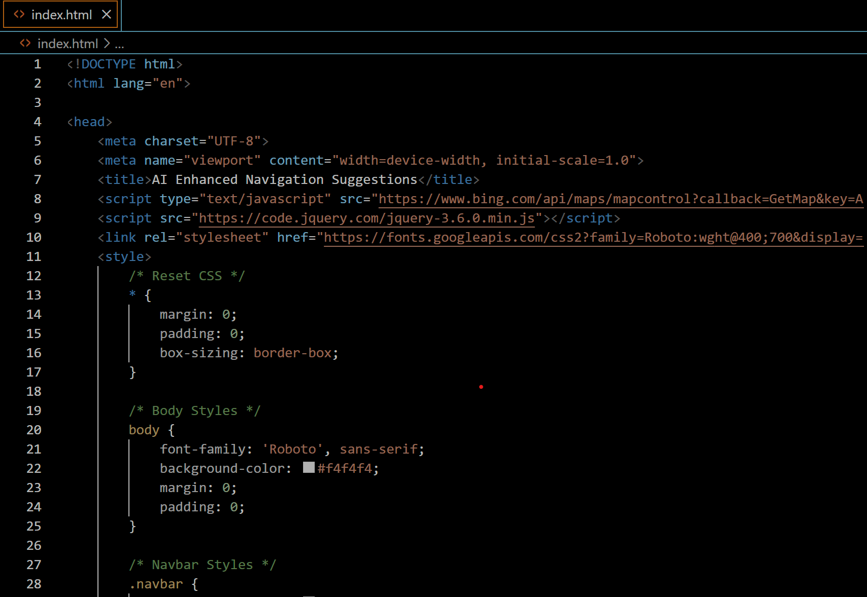

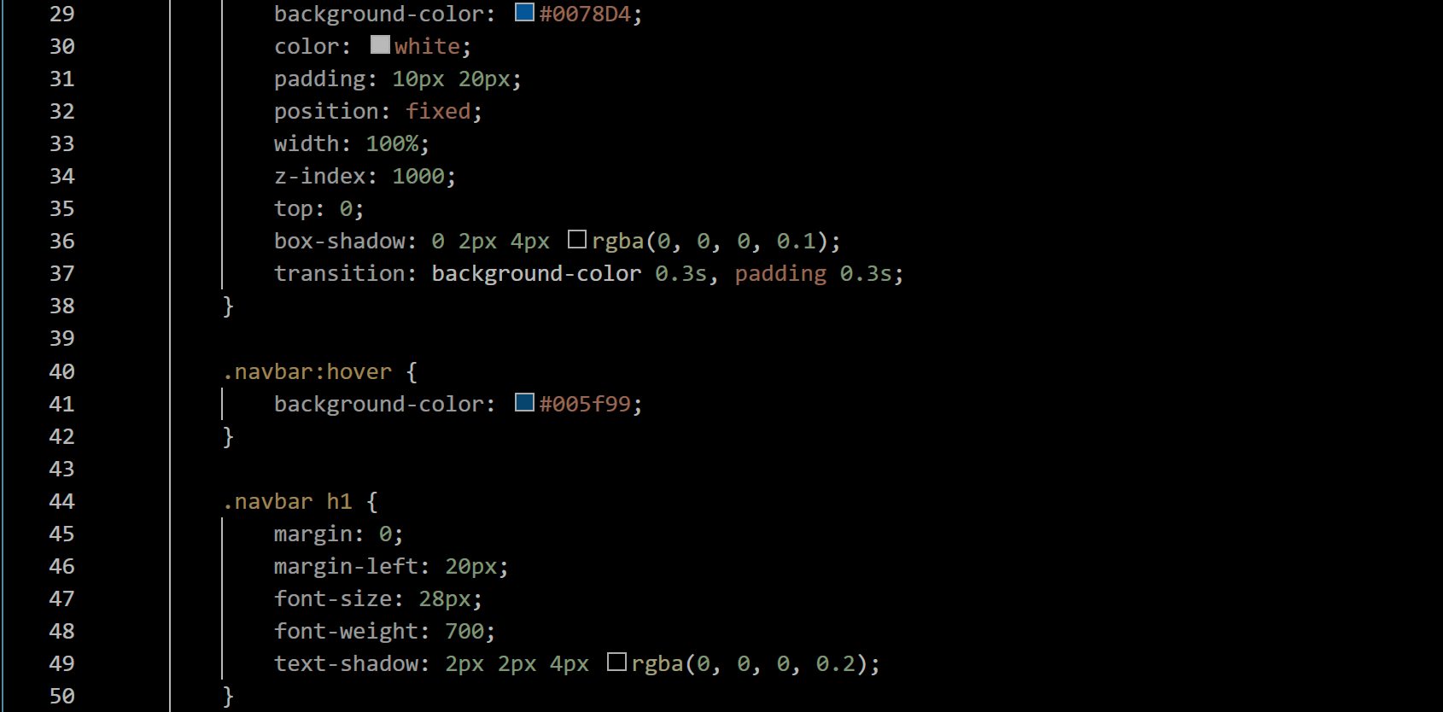

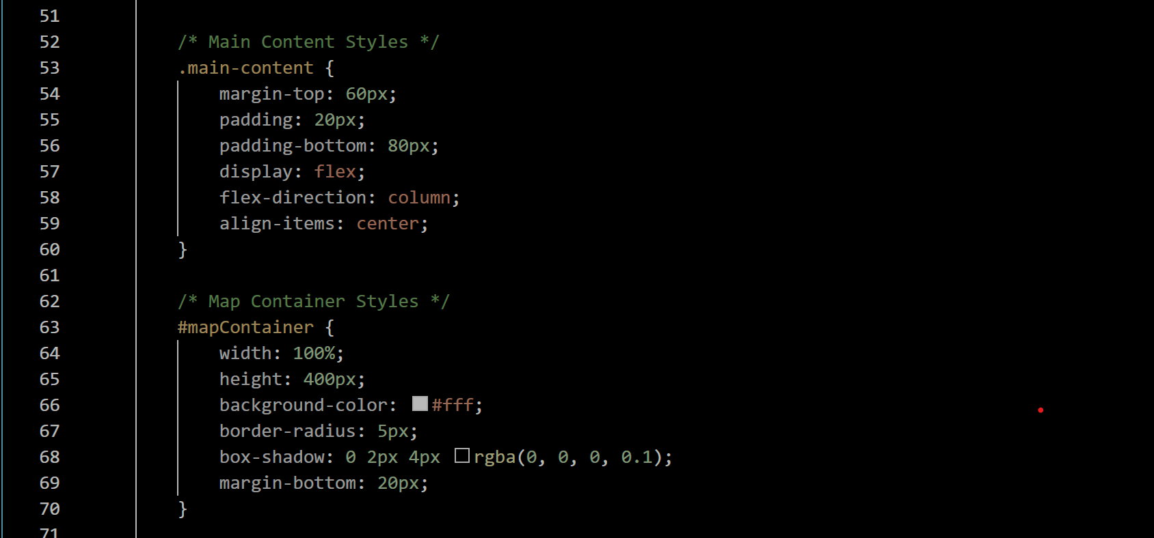

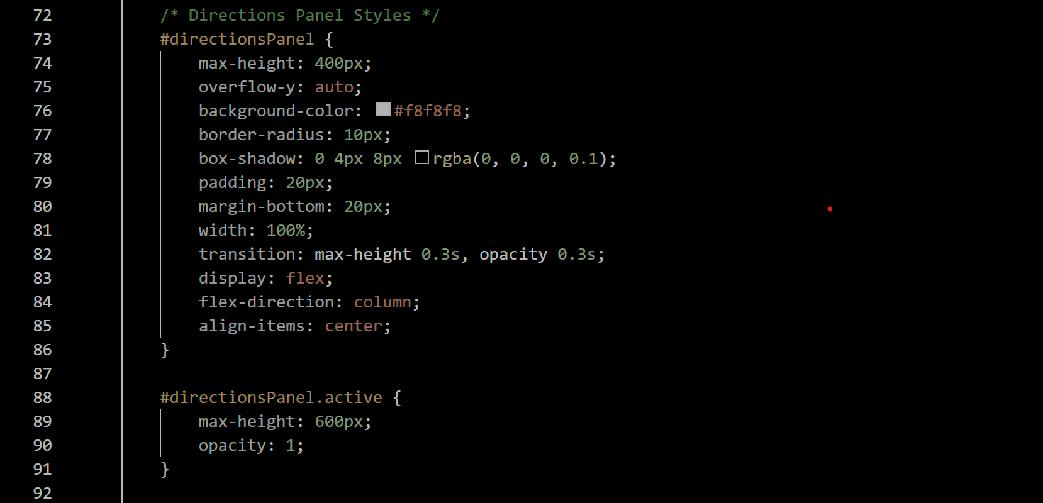

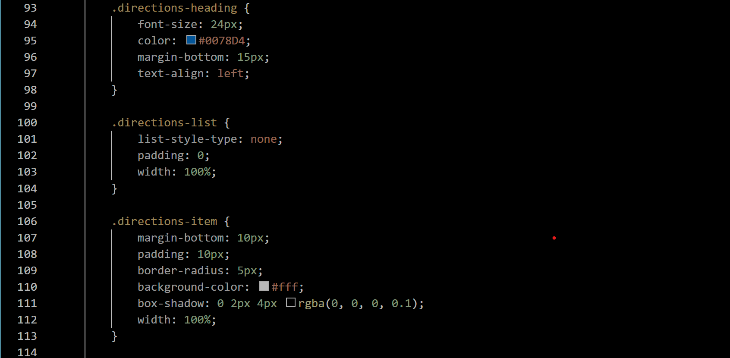

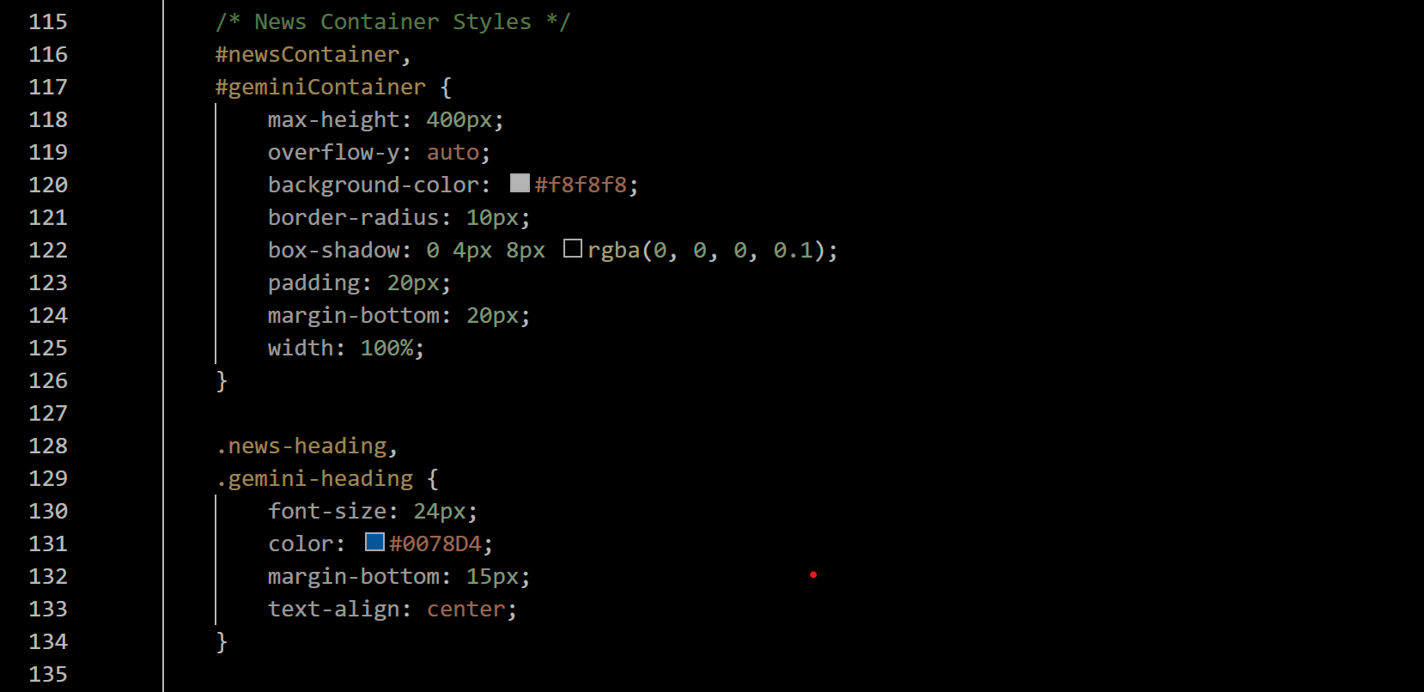

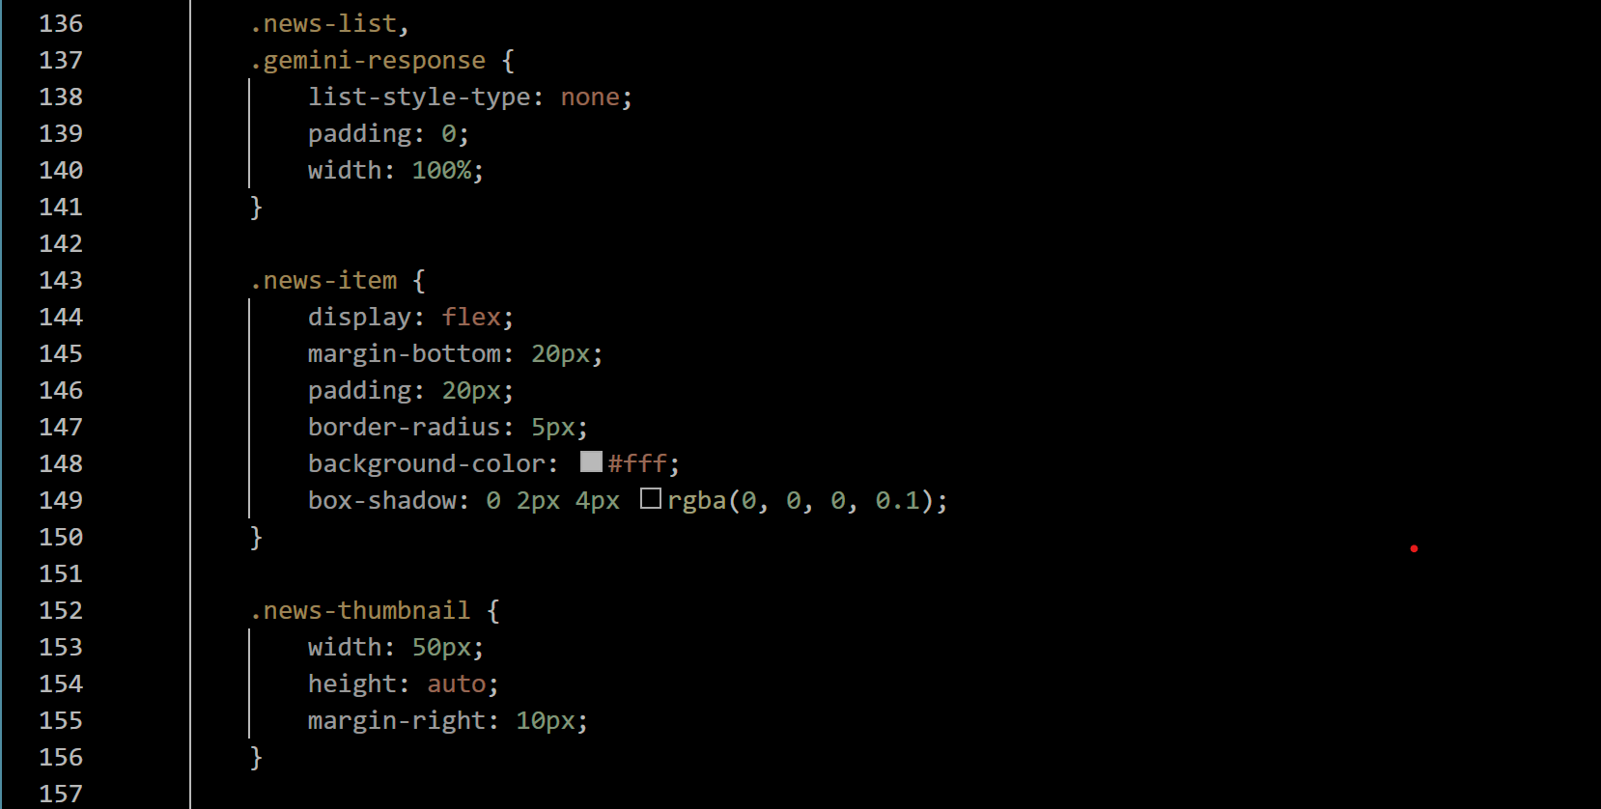



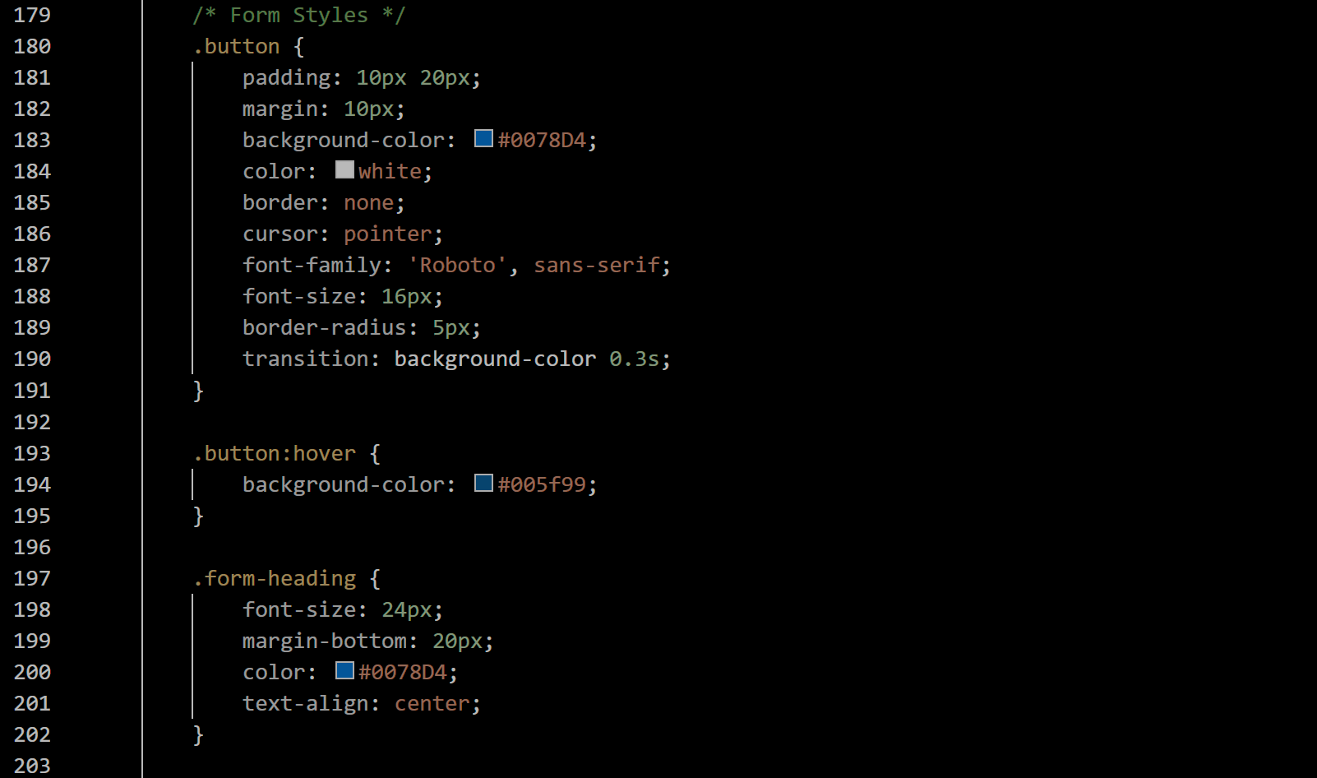

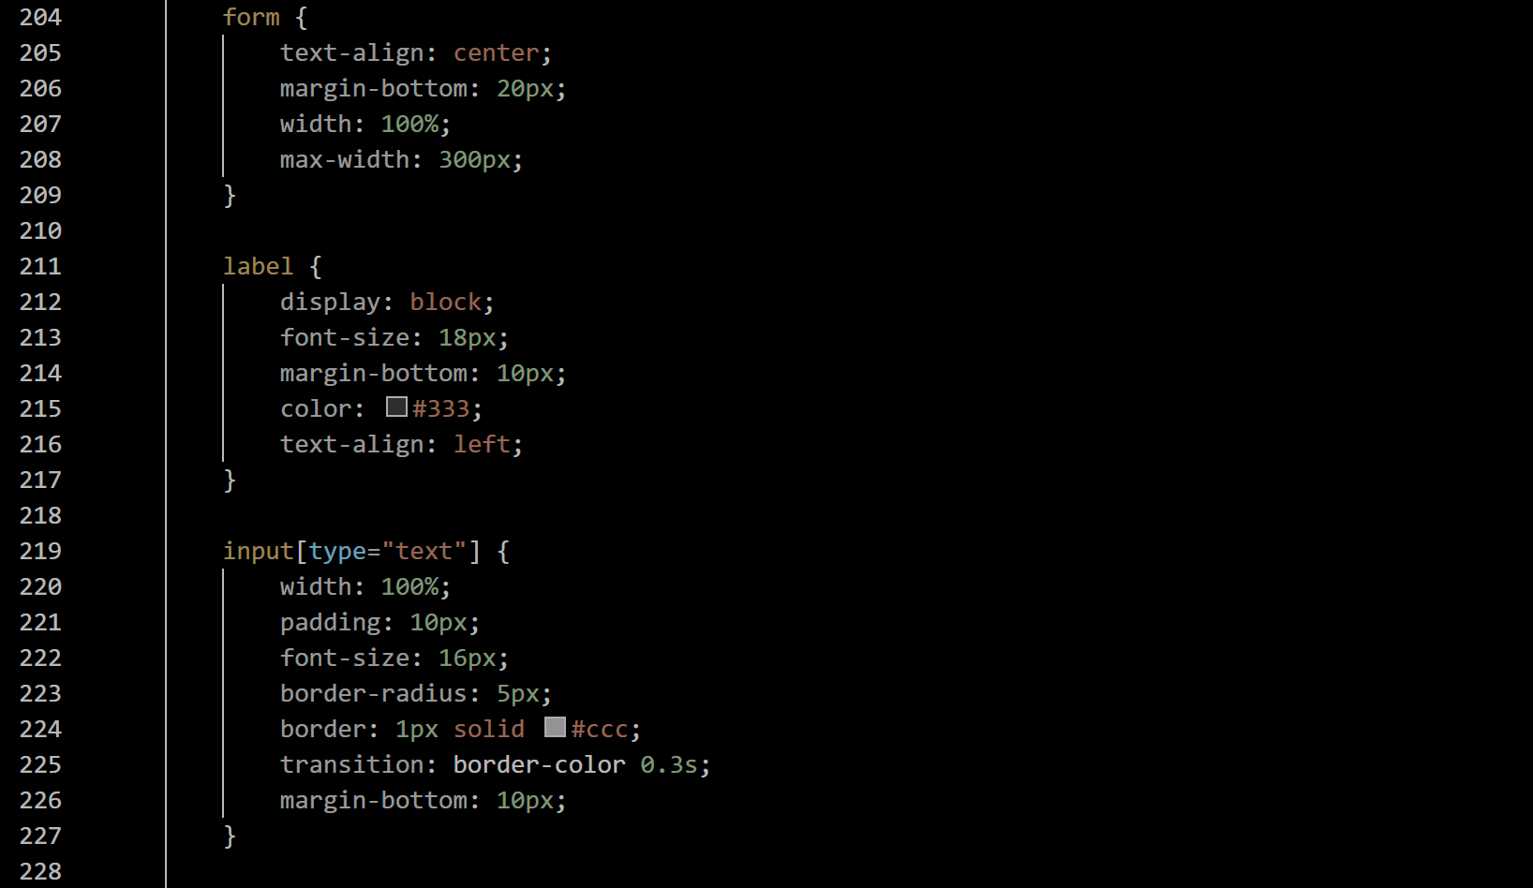

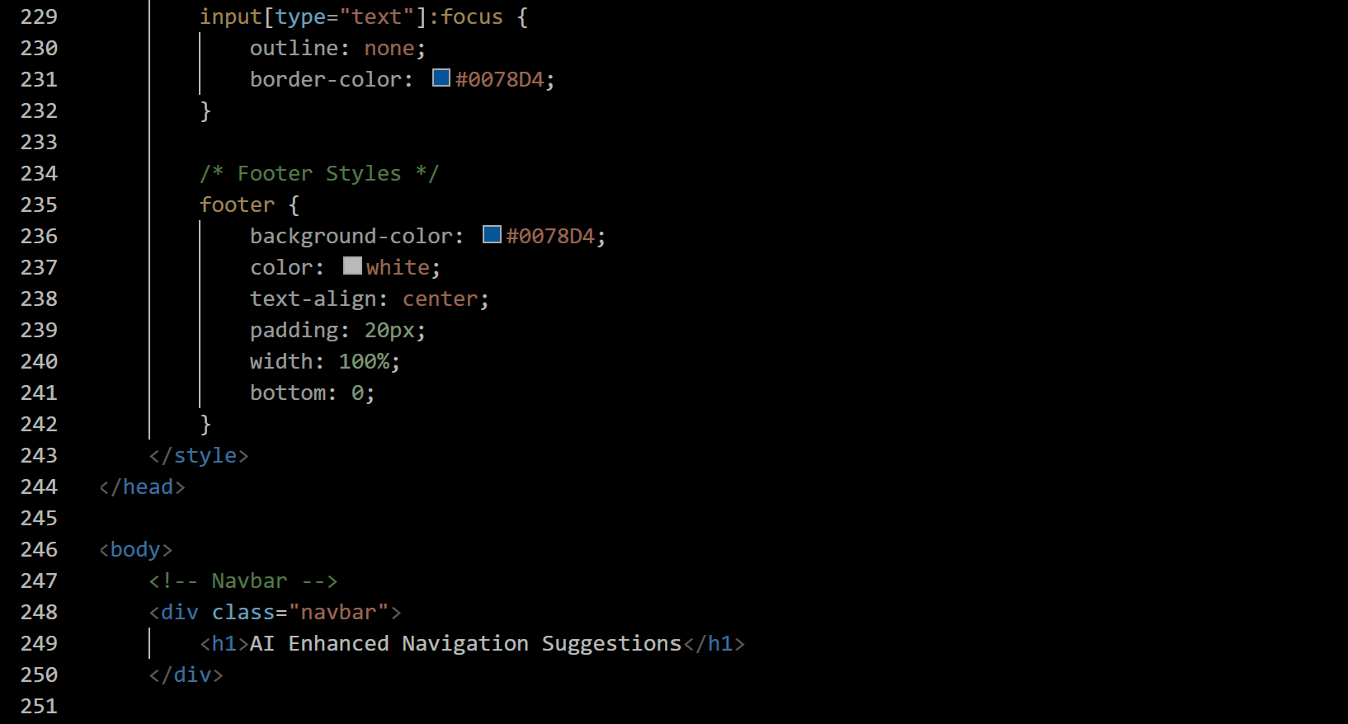

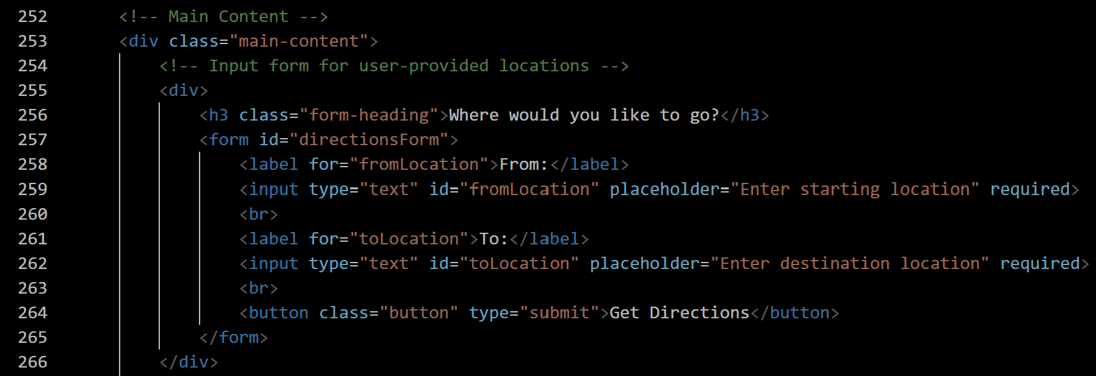

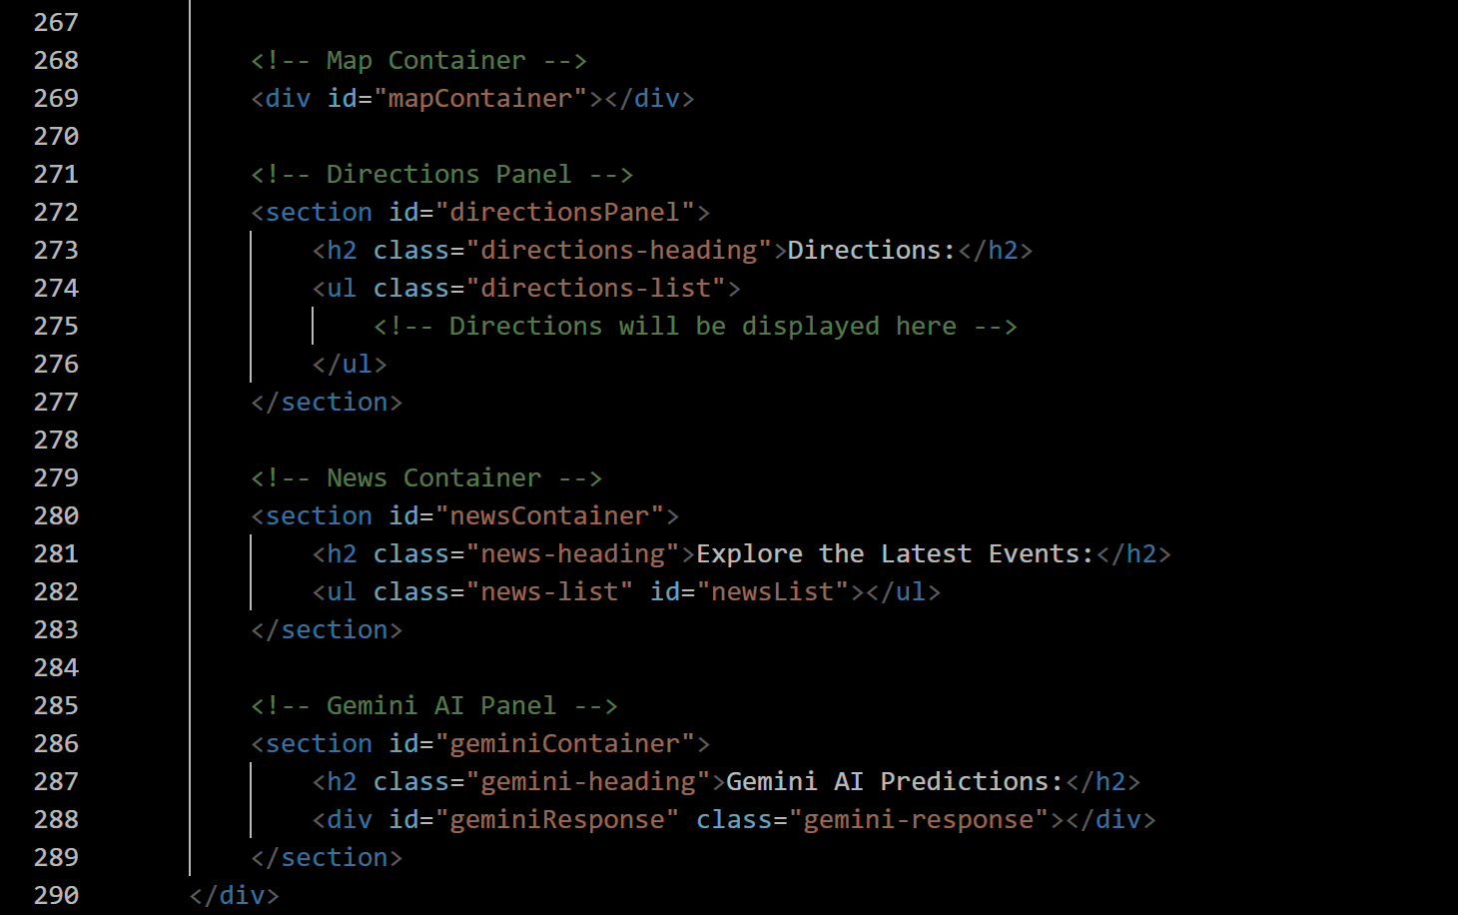

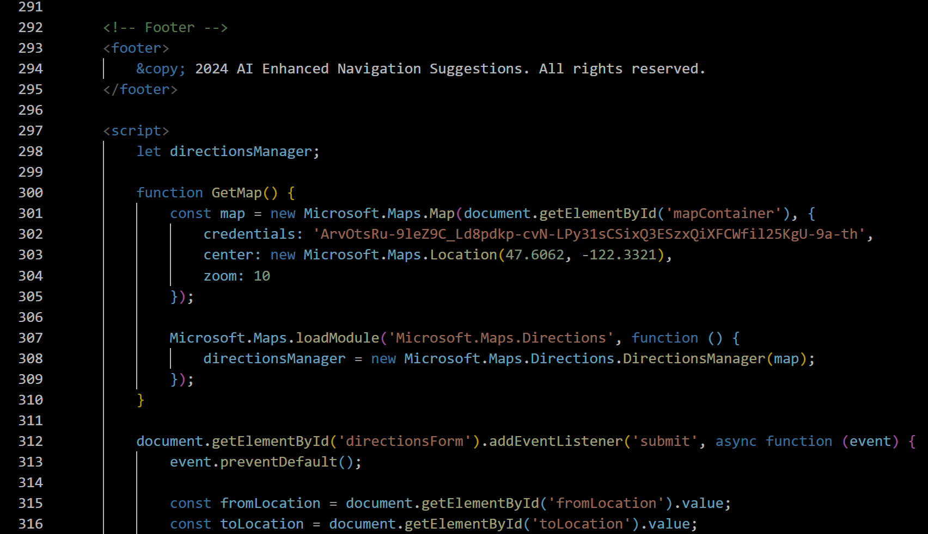

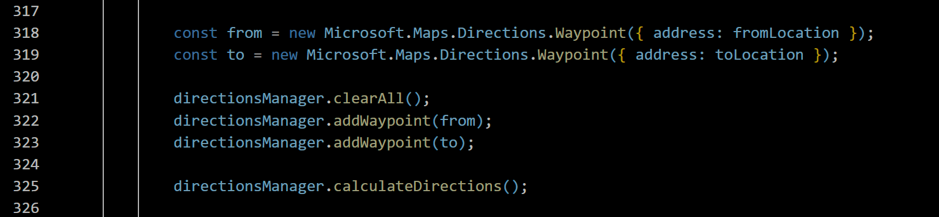

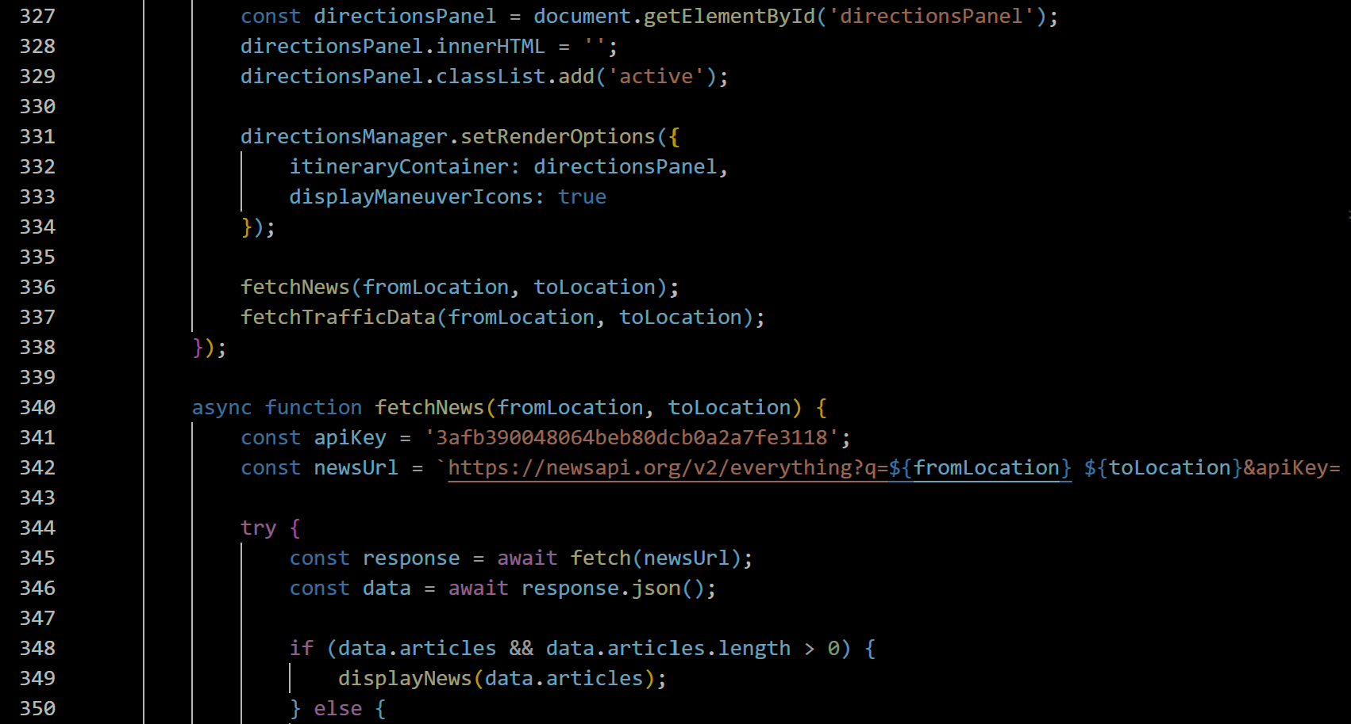

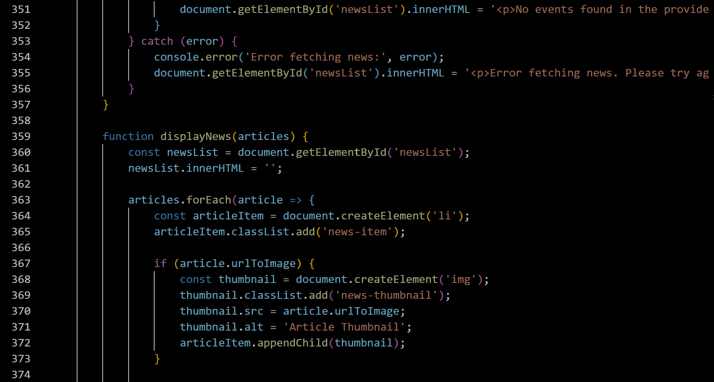

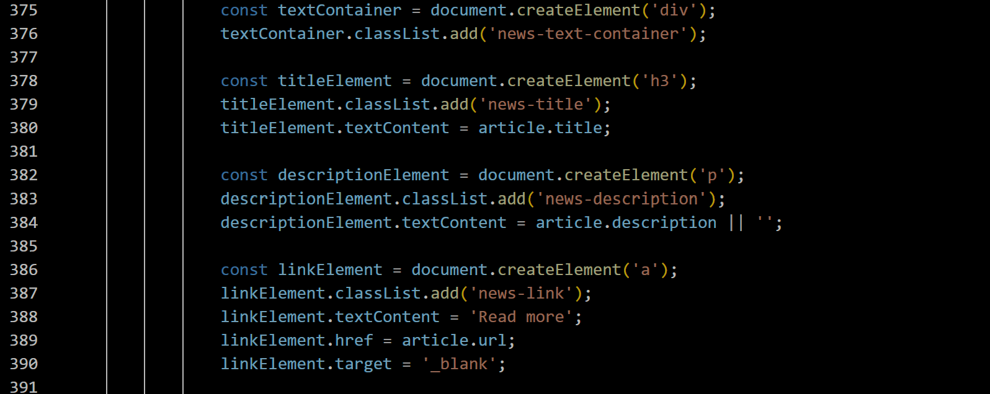

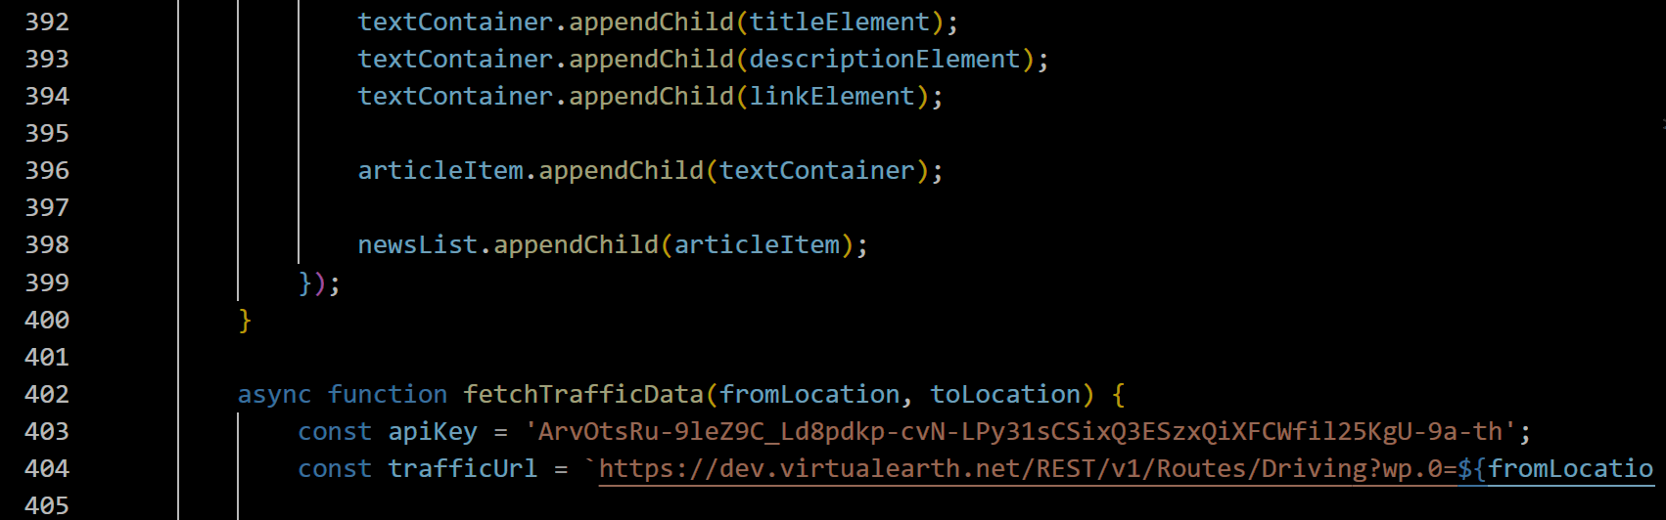

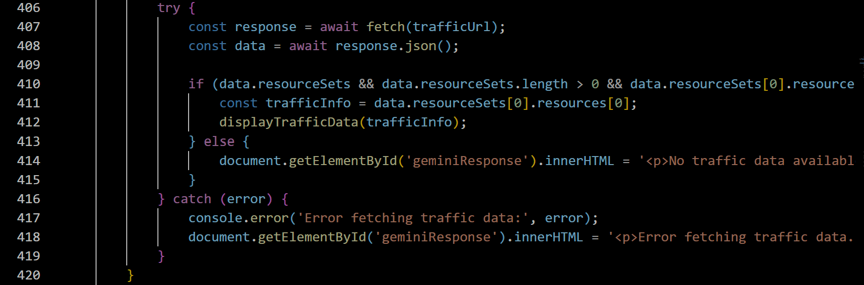

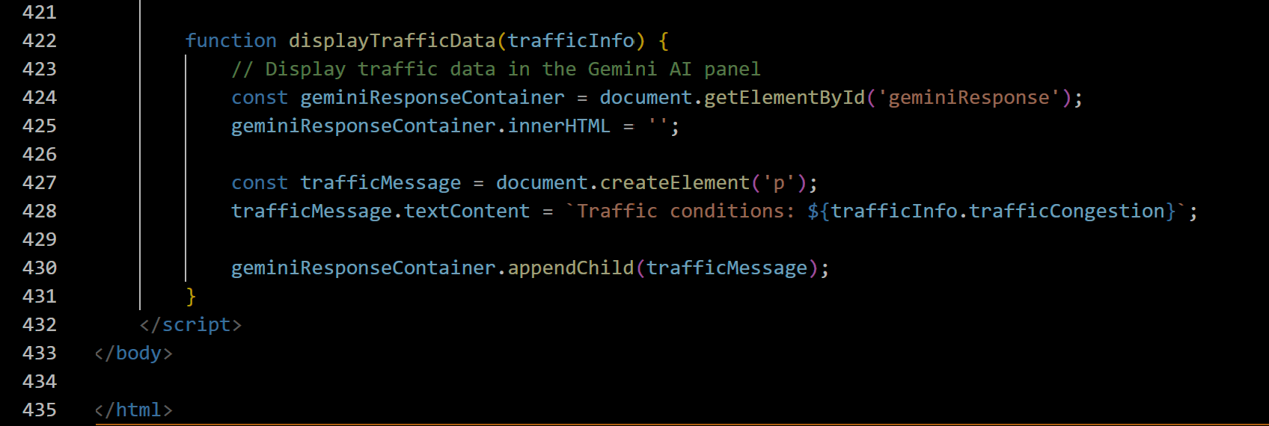

**Output:**



